Abstract— These instructions give you guidelines for preparing to perform a buffer overflow attack on a program that has a buffer overflow vulnerability. Countermeasures on how to prevent such an attack will also be discussed. Buffer overflow vulnerability is one of the classic vulnerabilities in software and has been around for decades and even today it is one of the most common vulnerabilities in software. The objective of this lab is to gain the first-hand experience on buffer-overflow vulnerability. A script is used on a vulnerable program to manipulate the program into running malicious code we want it to run instead of running what it was intended to run.
Buffer Overflow
Stephen Sottosanti, CS 428, and smsottosanti@crimson.ua.edu

Task One
Lab Definition—Such a vulnerability can lead to severe damage. In this lab buffer-overflow attack will be used to get root access on a system by taking advantage of a vulnerable program. An application called virtualbox is first installed on to your computer. A virtual machine is then installed from seed security labs website; this is because the virtual machine already contains the necessary programs in order easily complete this lab.

Figure 1.1 Vulnerable Code

Buffer Overflow Vulnerability Program
In the vulnerable program (figure 1.1) there is a strcpy function within the bof function which takes a string value and copies it into a destination. The main function takes a string str from badfile of size 517 and sends it to the bof function. The strcpy function does not copy up to a specific size so you can give it in more than what the destination can actually hold. The compiler will add until it reaches ‘\0’, so if it is not already somewhere in the string it will be added to the end of the string and the entire string will be copied into the buffer, no matter the size. If you copy something that is bigger than the buffer size, then you are going to cause an overflow.

Disable Security Measures
Ubuntu and other Linux distributions have implemented several security measures that will help prevent buffer-overflow from happening. Although they are not very reliable, they will be turned off anyways to make it easier to complete the buffer-overflow attack.

Figure 1.2 Turn off Randomization
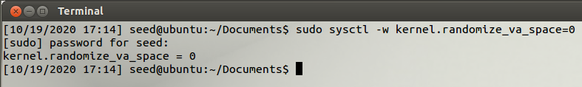
The first security measure to be turned off is the address space randomization. This randomizes the starting address of the heap and the stack. This makes it difficult to locate the return address since it is changing. A brute-force attack can be used to by-pass that countermeasure. As you can see in figure 1.2, that is how we are going to turn off the randomization.

The GCC complier implements a security mechanism called “Stack Guard” to prevent buffer overflows. When this is active, buffer overflow will not work. You can disable this protection by compiling the code in the following way:

$ gcc -fno-stack-protector stack.c

Ubuntu used to allow executable stacks, but this has now changed: the binary images of programs (and shared libraries) must declare whether they require executable stacks or not. They do so by marking a field in the program header. Kernel or dynamic linker uses this marking to decide whether to make the stack of this running program executable or non-executable. This making is done automatically by the recent versions of gcc, the stack is set to be non-executable. To change that, we will use the following options:

For executable stack:
$ gcc -z execstack -o test test.c

For non-executable stack:
$ gcc -z nonexecstack -o test test.c

Figure 1.3
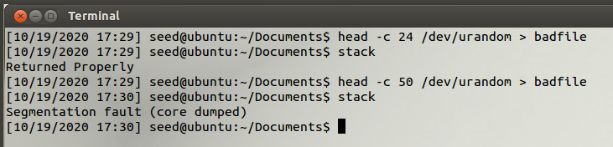

Watch Overflow in effect
In (figure 1.3) 24 random numbers were generated and sent to badfile. When the program ran it was fine because the buffer can hold 24 bytes or 24 random numbers in this case so it was not a problem but then after entering in 50 numbers to badfile you can see that there was an error when running the program. Even though the size of the input str is 517 anything over the size of 24 will cause a segmentation fault and cause the program to crash because that is all the buffer can hold.

Preparing for Attack
The return address of the bof function originally points to the code that you want to return to but after a successful buffer overflow attack the return address will be changed to the address where the malicious code is at. In order to successfully enter the address of the malicious code into the bof return address there are of couple of things you need. You will need to know where the buffer starts and ends, that way you can calculate the size of the offset. Once you find out where the ebp (end point buffer) and the buffer are located you subtract the edp address from the buffer starting address and that will give you the offset value.

How can we trigger our code? If we know the address of our malicious code and that address is A then we just have to put A into the return address which will return to the address of our code and execute it!

Figure 1.4
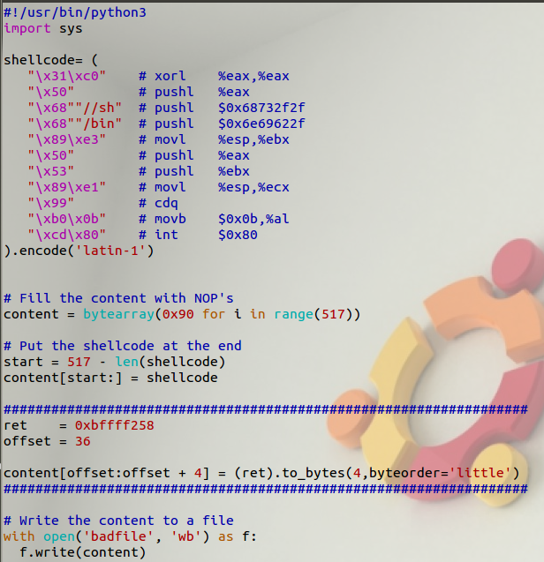

Before you start the attack, you need a shellcode. A shellcode is the code to launch a shell. It has to be loaded into memory so that we can force the vulnerable program to jump to it. Consider the program in figure 1.4

Now that we want to run our attack, we need to find the offset and once we find what that value is we need to put it in the return address. We need to put where our code is. The problem is we don’t know where our code is but we do not need to jump to the exact location of our code. We can create multiple entry points and as long as we can jump to one of them we will be able to get to our code. The solution is to add a whole lot of NOP (0x90) at the beginning of our source code. What NOP does is nothing other than move on to the next instruction. It will eventually lead to the entry point of our code. That solves one of the issues.

When finding the offset if we can find the ebp value and find out the buffer address then we can calculate the offset which is (ebp – the buffer address) and then add 4 because there are 4 bytes in between the ebp and the return address. Then we can return the ebp value plus an amount that will lead to one of our NOP and then we will get our malicious code.

Figure 1.5
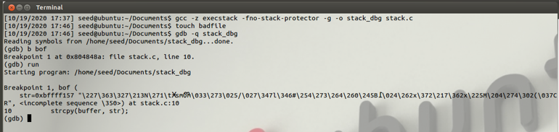

We are going to run a debugger (figure 1.5) and then have it stop at the bof function and run it. It will run and then stop when it reaches the bof function. Once the program stops, we can print out the ebp value and the value of the buffer.

Figure 1.6
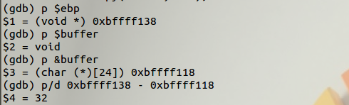
We then use the p command (figure 1.6) to print out the ebp value and you can see that value in the above figure. We can also print out the address of the buffer. We then can subtract the ebp value from the buffer value which will give us the offset value of 32. p/d will print out the difference between the two numbers. Remember the return address is 4 bytes above the ebp so the actual distance between the return address the buffer address is 36. We are going to fill everything above that return address with NOP and our code will be put in there above NOP. It will all be placed into badfile and then we will run the program with badfile. We just need to return to one of our NOP and we know one of our NOP is at ebp + 8. So, we just put our ebp value + 8 into the return address. When the bof function returns it will return to the NOP address that we put in.

In a real attack we do not exactly use that number. When you run the program with gdb the stack location is actually slightly off. It is a little bit deeper than if you just ran the program without the gdb. Instead, we can give it a lot of numbers. Add 100 or 120 and we can still be in the range we want to be in.

Figure 1.6
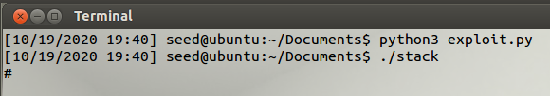

Knowing the value of the return address you need to be careful when adding another number to it. If the address is 0xbfffea98 and you decide to add 68 and now you will get 0xbfffeb00. Now the 0 byte that is inside the address which will end up stopping the program. When strcpy sees that 0 it will stop and nothing else will be copied.

The python script is executed and badfile is filled with NOPs, the address for our malicious code, and our malicious code itself. After running stack program, you can see in figure 1.6 that we get root access.

Address Space Layout Randomization

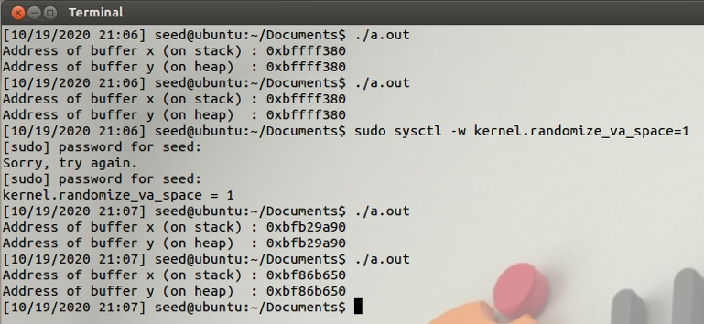

The main purpose of Address Space Layout Randomization is to make it more difficult for the attacker to launch the attack even if there is a buffer overflow vulnerability. In order to launch the attack, you need to know either the ebp value or the entry point of our code including our NOPs. We previously used gdb to debug the program and the find the ebp address along with the offset value. You probably won’t be able to do that in the real world. You don’t always have access to the source code. What attackers do is just guess. Guess the address of the code and guess the address you can put in the address field. If the guess is not that difficult than the attack will still be effective. If the guessing is too hard than it is going to be hard for the attacker to successfully preform the attack.
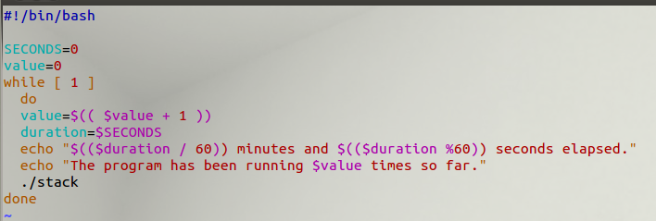

It turns out it is not that hard. Most of the OS allocates a block of memory for the stack. They allocate this memory in a fixed location in the virtual address space. The starting address of the stack is always fixed. How difficult it is to guess depends on how deep the stack is. When it comes to programs that use recursive function, every time you call yourself you add a new stack frame to the stack. In those kinds of programs, the stack can go very deep. In most cases you do not write recursive functions. Since the stack is not very deep it is going to be very easy to guess where the code is. Address space randomization makes it difficult to guess where the code is, but not impossible.

Non-Executable Stack

The stack is primarily used for storing data why should it be allowed to run code. If you can make the stack nonexecutable then even if you put the malicious code on the stack it is not going to work.

Inside the header of your program binary, the first bit says when you allocate memory for my stack please make this stack executable or nonexecutable. It is up to the program to decide what option you want unless you are running on a nonexecutable stack.

StackGuard

The stack guard will add a marking between the buffer and the return address so in case you have overflowed the buffer, and this endangers the return address the program will automatically stop.

Conclusion
In conclusion, the vulnerable program was used to get root access to the system. Even after turning randomization back on, using a brute force attack still allowed you to get root access.

Buffer overflow is one of the oldest and most common attacks you will see on software. There are many ways to exploit such a vulnerability and there are many countermeasures to prevent it. I wonder if it will still be around in 10 more years.

 Manuscript received September 21, 2020

